PLAINWEAR PROJECT

PLAN

GROUP 3 DashBOARD.

Version: 2.0

Mark/Nguyen Phat Thien Phuc.

Stefan Angelov.

Jędrzej Kajkowski

Tim Van Lierop.

Anouk Min.

22-9-2020

Contents

**Introduction:** 2

Project definition 2

Assumptions and Constraints 2

Project Organization 2

Project Scope 2

Project Goal 2

Project Deliverables and Deadlines 3

Project Non-Deliverables / Out of scope. 3

Management Overview 3

Budget 3

Points of position 4

Contact information: 4

Implementation Plan 5

Risk Analysis. 6

Project Risk Table 6

18 Week Backlog Define Task: 8

# **Introduction:**

### Project definition

Plainwear is a well-known clothing store. Because the fashion industry is changing so quickly, a store is sometimes temporarily closed to renovate it so that it is up to date again. Because it is a large company, it is sometimes difficult to see how stores are doing individually. Now the task is to create a system in which it can be kept track of when a store is (temporarily) closed. The CFO also wants to see how stores are performing. They got some problem and optimize trouble when using Excel now. We present for a team to make another version of data showing in PowerBI Dashboard which match with their expectation and fix their problem when using excel. With combination of explicit point of IT and Business integrated into the project.

### Assumptions and Constraints

The intention is that we create a dashboard that shows all data from the stores. You can also filter there. Before we get to that we will have to make all kinds of preparations. We also make a Business plan and an implementation advice

* Schedule: 17 Weeks
* Skill need: R and PowerBI.
* Software: PowerBI Application.

### Project Organization

The stakeholders in this project are the team members: Mark/Nguyen Phat Thien Phuc, Jedrzej Kajkowski, Stefan Angelov, Anouk Min and Tim van Lierop. The client, to whom we must present our final prototype of the idea, is Plainwear.

### Project Scope

For this project we must make a dashboard with loads of drill down options on the main data. We look at the Like4Like categorization the company uses. This means we compare stores based on their status; New store, Open store, Closed store, Re-fitted store. The most important thing is to have an easy to use dashboard in which the client can see how certain stores are doing based on revenue. It has to be easy and intuitive because everyone in the company will use this dashboard

### Project Goal

The main goal that this group has set for the future is creating solution for the clumsy keeping of the data. This is still done manually in Excel. This of course makes it easy to make mistakes and it also takes a lot of time. That is why we want to create a dashboard in which all data about all stores can be found and display in one convenient application. With the aim to make it simple for user and avoid complexity manual.

Ultimately to achieve our goals, our complete solution can be summarized as such:

* An IT solution (Dashboard) / Not only that we should provide as the business way to make solution provided smoothly which help the employee from Plainwear easy to use and maximum the efficiently.
* Focus on the business viewpoint and optimize the DashBoard on PowerBi which gave they a simple guideline and easy to use.

### Project Deliverables and Deadlines

The deliverables for this project include:

|  |  |
| --- | --- |
| **Deliverable** | **Deadline** |
| Business advice | Week 6 |
| Dashboard | Week 12 *\*Do note, this is our deadline for our own MVP (minimum viable product), the actual deadline for the finished dashboard is week 17* |
| Implementation plan | Week 17 |

### Project Non-Deliverables / Out of scope.

The project non-deliverables are meant to display a list of processes/components that will NOT be included in our project/solution:

* Extensive IT solution (advanced functionality is not our priority).
* Any software that needs licensing.
* Only software solution, not hardware
* The full implementation of the project (Hiring employees and executing project)
* The assumption from us which haven’t verify by the client.
* Building the R solution and SQL server for the project.
* Focus on the technical part and abandon the business site of the project.

## Management Overview

Being a group project, we set out to identify where our skills lie. After doing that, we wrote down our results alongside our desired outcomes of this project, which assisted in setting out goals for acquiring new skills. To utilize our management skills, we set up a step by step task implementation plan, through which we can monitor our progress. The list goes as:

## Budget

Mainly discussion and deal with Plain Wear Department. For this project we did not get a set budget

## Points of position

### Contact information:

|  |  |
| --- | --- |
| Project members | Client and Tutor information |
| Mark/Nguyen Phat Thien Phuc (3767507)  Project Communicator / Tech Developer  Stefan Angelov(3787982)  Analysis & Research  Jedrzej Kajkowski (371664)  Teach Lead Developer.  Anouk Min (371664)  Business Developer / Researcher  Tim Lierop (371664)  Strategic Director | Mr.Marco  Tutor Project.  Marco.hormes@fontys.nl  Miss Siva  Mentor for Project.  k.sivaramakrishnan@fontys.nl  Clients:  PlainWear Financial Department. |

# Implementation Plan

# 

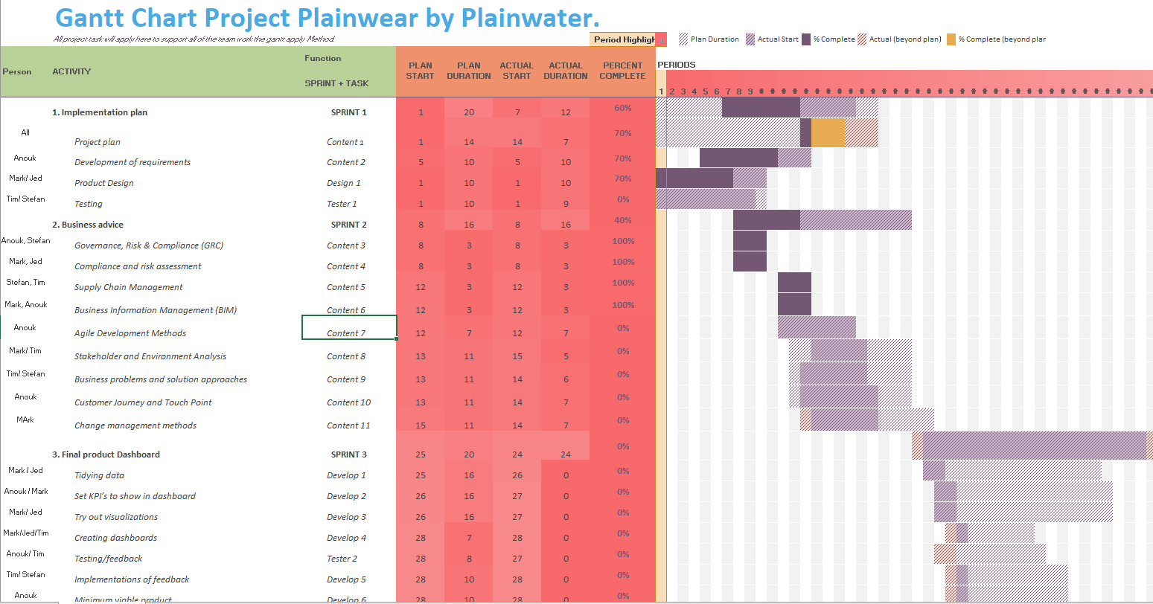

Figure 1 Gantt Agile Process From Sprint 1 to Sprint 3

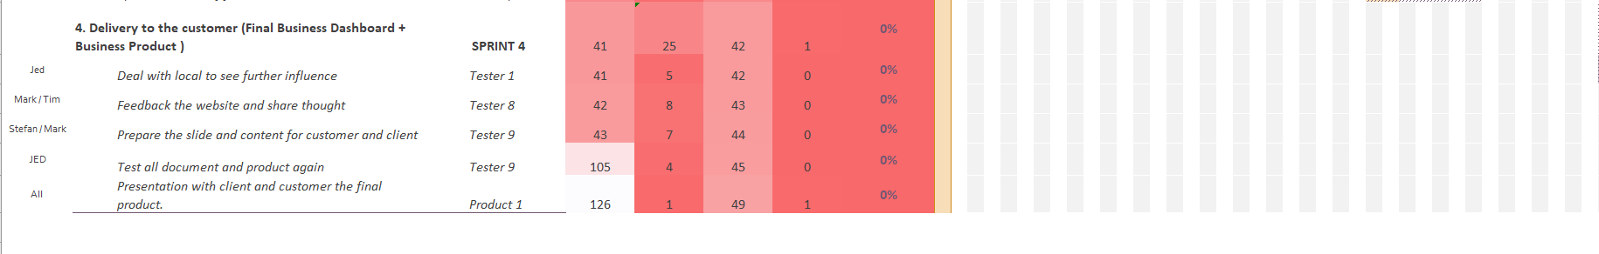

Figure 2 Gantt Chart Agile Process Sprint 4

# Risk Analysis.

Business Risk Analysis integrate with security information standing.

|  |  |  |  |  |
| --- | --- | --- | --- | --- |
|  | | Probability | | |
| Low | Medium | High |
| Impact | Significant | Substantial management required | Must monitor and manage risks | Extensive management crucial |
| Moderate | May accept risks but monitor them | Management effort useful | Management effort required |
| Minor | Accept risks | Accept risks but monitor them | Monitor and manage risks |

## Project Risk Table

The project risk table is part of the security section of this report due to the fact that it illustrates possible project risks using color schemes. The legend is presented in the first table, which uses colors to address the severity of each task.

|  |  |  |  |  |
| --- | --- | --- | --- | --- |
| Risk Type | Risk Probability | Risk impact | Prevention | Solution |
| Not managing to complete set targets before internal deadlines. Example: certain required documentation | Low (Team is familiar with scope so the planning should be mostly accurate). | Moderate (worst case core features need to be cut & weakened documentation). | Planning a time pipeline, make minutes of meetings and consider each task by priority versus implementation time. | Cut down on lower priority features, or push back tasks to between internal and final deadlines. |
| Client displeased with current direction and drastic changes are required to adjust. | Low (As we have started with a good scope of the client’s desired direction and there is little room for ambiguity). | Significant (likely cannot cope due to distance between group members). | Clear agreements and frequent check-ups. | Find compromise and adjust existing features to better suit the demands of client. |
| Unable to link any software systems to function in unison. | Medium (can vary with how many systems are not cooperating, such SQL Connect Data, or client data may change during the project depend on business situation). | Significant (most software solutions are next to useless if they cannot communicate with each other). | Leave plenty of time to address this specifically. | Might be forced to cut functionalities of problem cases, or work with whatever leftover time. |
| Conducting field research. | High (as far as we know, conducting field research will be impossible for a while due to shutdowns) | Low (Field research is not the most important detail) | Using the business detail from the client Plainwear without assumption | Verify with the client before executing any solution in the Dashboard. |
| Dashboard set-up | Low (Maintaining such a low probability is vital | High (Prototype is crucial for client to get a proper overview) | Proper preparation and implementation | Assign member to be responsible for task at hand. Prepare plan and work on it early |

Risk of team management in business site.

|  |  |  |  |  |
| --- | --- | --- | --- | --- |
| **Ratio** | **Human Risk** | **Environment Risk** | **Solution** | **Risk Weight** |
| Basic | Team less work with sickness | City problem may hard to dig information | People share task and handle together | 5 |
| Intermediate | Team Lack of communication | Location meeting changing | Being flexible with team member | 4 |
| High Level | Team Decision possible to interrupted. | Lack of Technical skill | Learn it every day to prepare right skill, keep ask ourselves which one should learn and not. | 5 |
| Intermediate | Solution might be hard and advance | People don’t agree the same idea. | Start to harmonize difference perspective and thought from team member. | 3 |
| Intermediate | Lose Track | Project run to some misdirection target. | Always ask and criticize in what we are doing. Getting feedback with mentor. | 4 |
| Extreme | Corona Virus Attack | Everyone getting off from main locations and stay at home | Work from home and contact with client and business owner online | 5 |

#### Security Setup During Implementation

To maintain security of our setup documents, all our files are stored in locations only accessible by team members, and any document being sent is extracted from there. We also work hard to maintain originality in our documents by not looking too deep into other similar projects. We also accept git to upload our project in.

# 18 Week Backlog Define Task:

We follow the agile process which applied for the teamwork. / We are adding our milestone into the process of agile.

|  |  |  |
| --- | --- | --- |
| **Week** | **Task works** | **Learning goal to build the project** |
| **Week 1 to Week 2** | Planning for the project, meeting with the customer and interview with the client.  Verify the assumption with the Plain Wear company. | Project Plan, Business Function Skill. ERP, Information Management. |
| **Week 3** | Decide to analyse the solution and making the processing for the plan. And delegate task for team-member.  Technical Team will be working with importing data into SQL. To look at the data and understand it. | Planning on PERT CHART, GANTT, ready technical basic skill for next step.  Delegate the good work for by break down structure for each team member. |
| **Week 4** | Prepare the Agile, Sprint carefully and research the root cause for solution and business advice brainstorm with team member. | Apply Business Measure and logic step into the project.  Dealing with Stake Holder and form the budget for the project. |
| **Week 5** | Giving the draft for solution which based on the point of company problem. -> Draft Version for the Business Advices.  Ready Technical Skill To working with Dashboard Solution for the customer. | Windows R Function and Dashboard Dax languages to make some draft in the Dashboard.  Apply business management skill in the project to learn about business advices. |
| **Week 6 to week 7** | Testing the Business Advices with the team and verify with the client.  And delivery a good business advice for the client.  (Help them form a good vision about what kind of product we will build, and clear expectation with their need and demand for the solution in it site and business site) | How to understand and apply business knowledge into customer advices, to give them understand and compressive business advices which belong to our project convenience benefit. |
| **Week 7 to week 8** | Sprint week for basic dashboard and product technical development.  Going through Data KPI, analysis, process, cleaning, and build the graph from R to validate in PowerBI  Going to some verify step of technical prepare with the tutor. | Learn how to build the good structure and foundation for the efficient data to connect to PowerBI.  Also apply building R Window Function. |
| **Week 10 to Week 12** | Prototype research for Business Method and Business Approach in Dashboard with customer.  From the data we starting to build the dashboard for the customer and client. | Develop the proper dashboard for the first draft. |
| **Week 12 to Week 17** | Sprint the complete the last version of the project and prepare for stake holder, plus presentation for the project | How to deliver a product business to the customer. |

*This table show how we implement the task activities, follow our user stories. And learning process.*